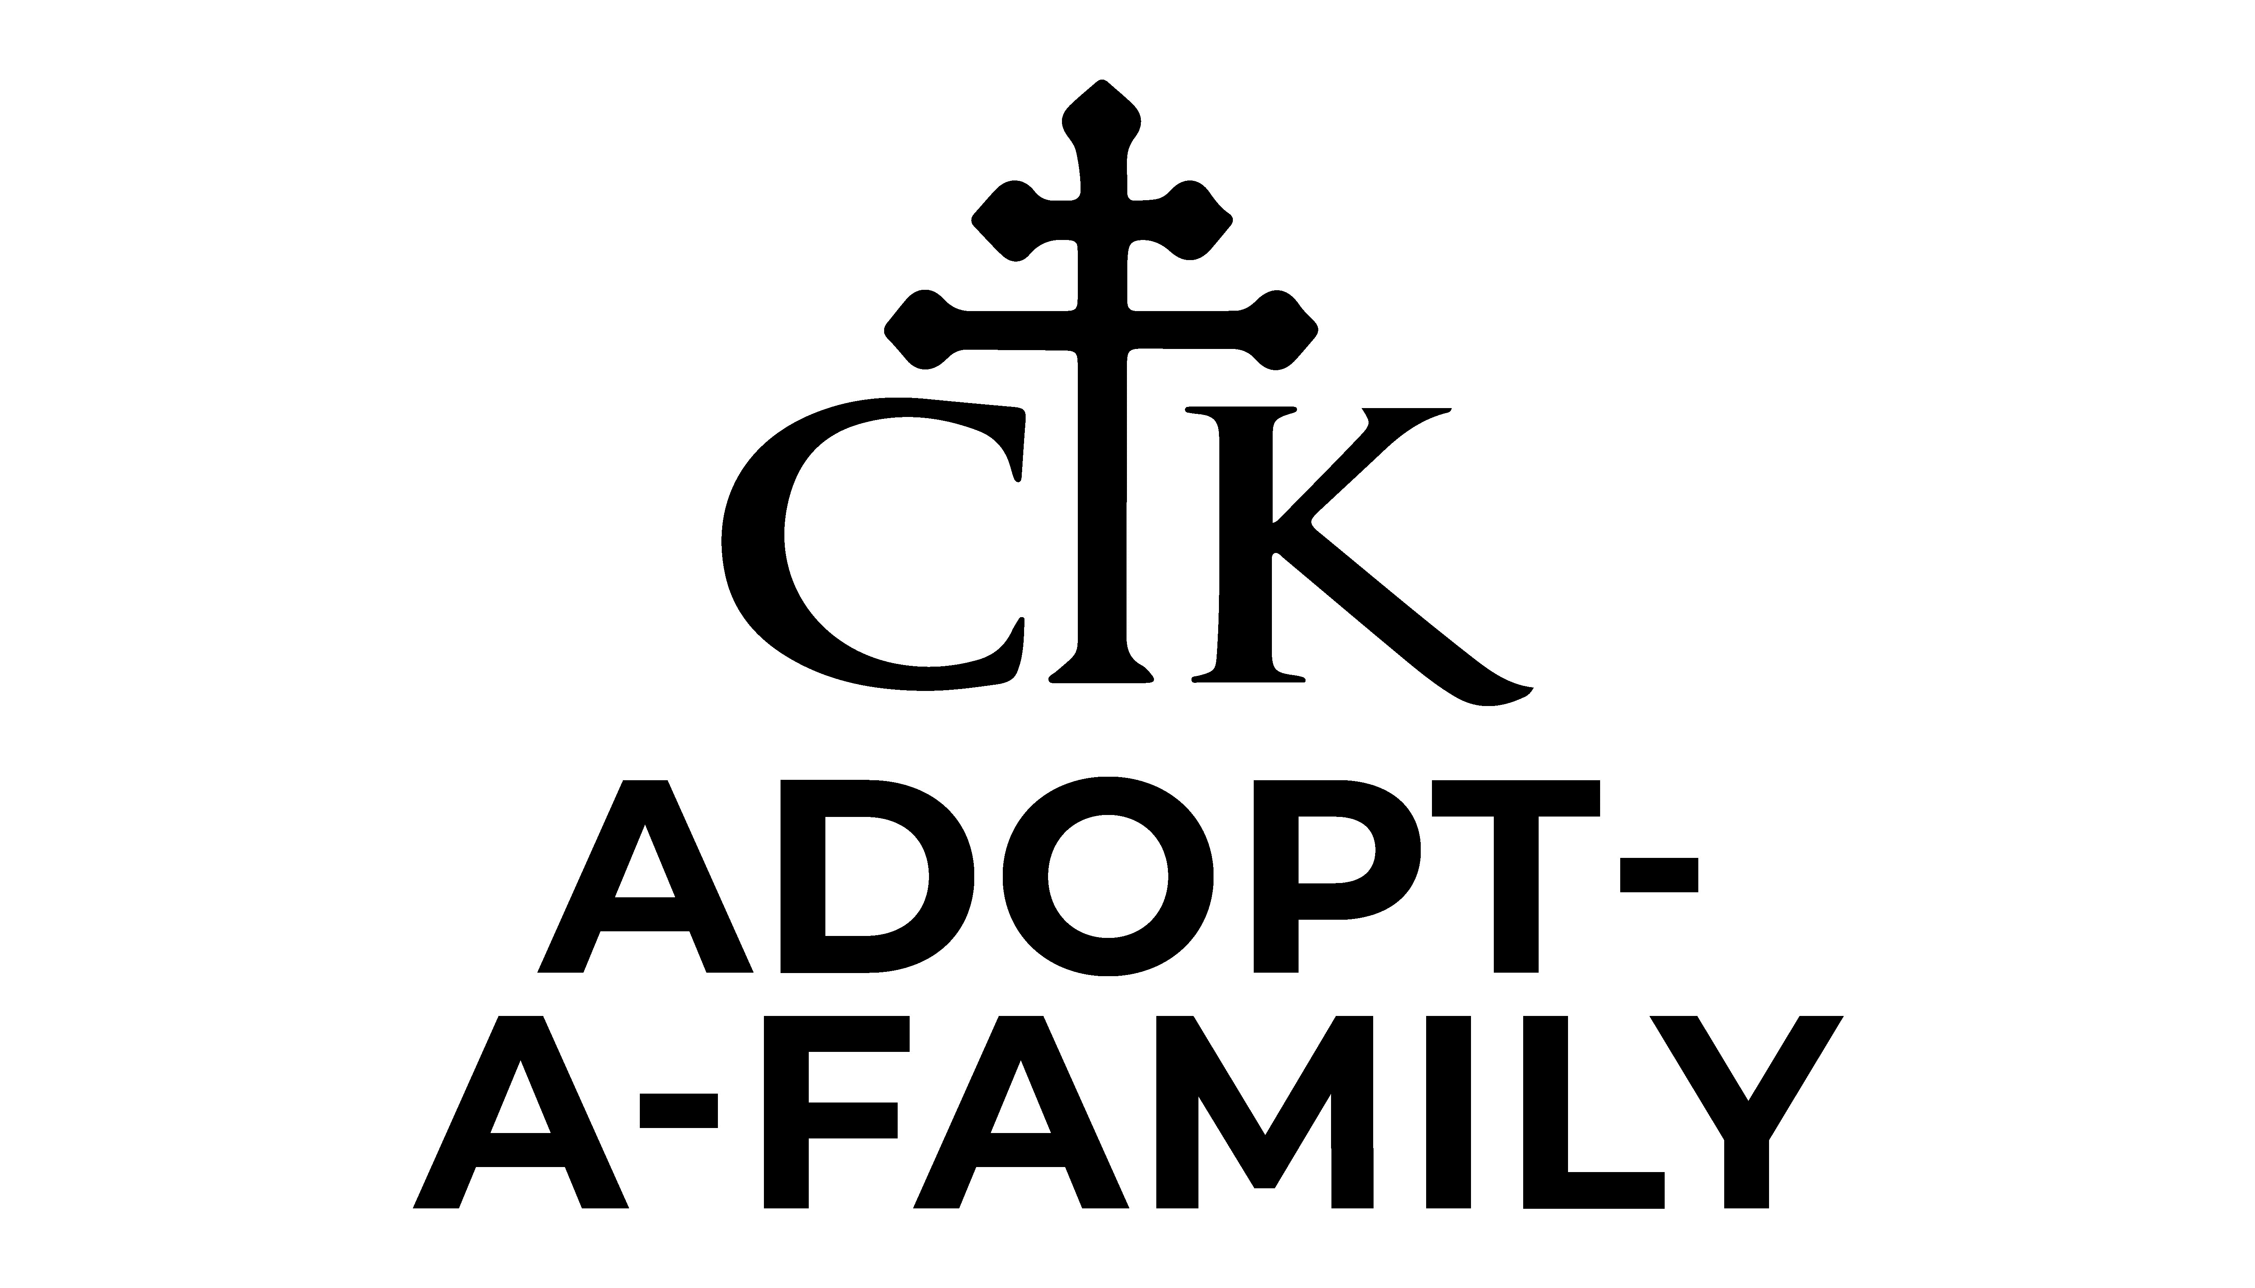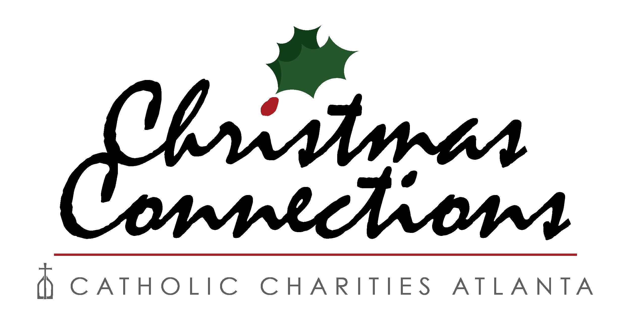

Christ the King is proud to sponsor the 2024 Adopt-A-Family Program. We hope you can take part in this wonderful program which offers you the opportunity to share your blessings with others. This is one way you can reach out to those in need!!! We work with Catholic Charities, Hispanic Ministries, Divine Mercy Mission, Archdiocese of Atlanta Disabilities Ministry, St. Joseph, and St. Vincent de Paul. All families participating in this program have been screened and are in dire need of your help.

Here’s How It Works:
- Once you have decided to adopt a family, please email the size family you would like to adopt to the email listed below, or you can sign up online on the CTK website: http://cathedralctk.com/outreach/adopt-a-family/
- In the next couple of weeks, you will receive the wishlist sheet via email on the family you adopted. The wishlist sheet will include the names, ages, special requests of the parents and children, as well as the suggested gift items. You will also receive packing instructions, delivery date and times, and the tax receipt form in this same email.
- We ask that you, the sponsor family, provide 3 gifts per family member and a food gift certificate. We estimate $75/ family member plus the food gift certificate for $25/ family member.
- DROP OFF LOCATION AND TIMES: All gifts need to be dropped off in the Second Ponce lower parking lot on Thursday, December 5th (12:30-2:30 pm; 4-7 pm), at the corner of E. Wesley and W. Bolling.

You can help make the holidays a great time for those families less fortunate. The Adopt-A-Family program is a way to get your entire family involved in sharing your many blessings with those in need. Last year, the program helped over 1,000 families throughout Metro Atlanta. We hope to exceed that amount this year. Thank you for considering adopting a family this year and helping us reach our parish goal of over 700 families.

There are two family sizes – Small (families with 2-4 family members including parents) and
Large (families 5 or more members including parents)

For those interested in adopting a family or if you have specific questions about the program, email your request to the following:

Isabel Rice adoptafamily@ctking.com 404-717-9589

“What so ever you do to the least of my brothers, that you do unto me.”
CTK 2024 Adopt-A-Family Program
Name
Email
Phone #

We’d like to adopt a Small Family (families with 2-4 family members including parents)
We’d like to adopt a Large Family (families with 5 or more members including parents)

Return to Outreach Ministry by emailing adoptafamily@ctking.com

